1. Shape (Area + Display)
class Shape {
// Overloading
void area(int a) {
System.out.println("Square Area: " + (a * a));
}
void area(int l, int b) {
System.out.println("Rectangle Area: " + (l * b));
}
// Method to override
void display() {
System.out.println("This is Shape");
}
}
class Circle extends Shape {
// Overriding
void display() {
System.out.println("This is Circle");
}
}
public class Main1 {
public static void main(String[] args) {
Shape s = new Circle();
s.display(); // overriding
s.area(5); // overloading
s.area(4, 6); // overloading
}
}
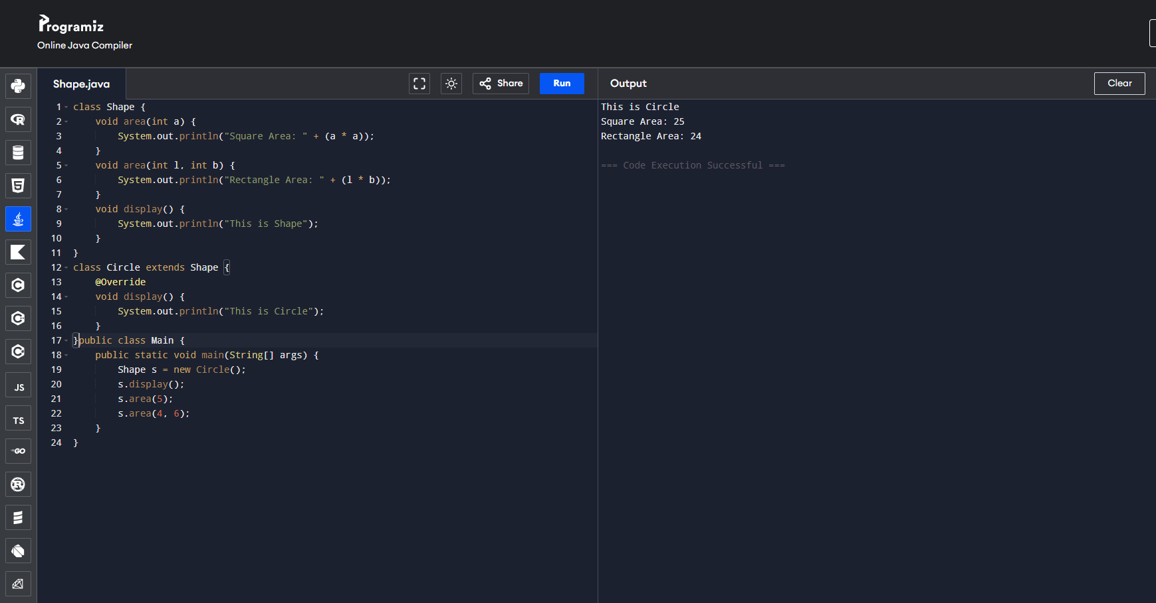

🔹 2. Calculator + Scientific Calculator
class Calculator {
// Overloading
int add(int a, int b) {
return a + b;
}
double add(double a, double b) {
return a + b;
}
void show() {
System.out.println("Basic Calculator");
}
}
class ScientificCalculator extends Calculator {
// Overriding
void show() {
System.out.println("Scientific Calculator");
}
}
public class Main2 {
public static void main(String[] args) {
Calculator c = new ScientificCalculator();
System.out.println(c.add(2, 3)); // overloading
System.out.println(c.add(2.5, 3.5)); // overloading
c.show(); // overriding
}
}
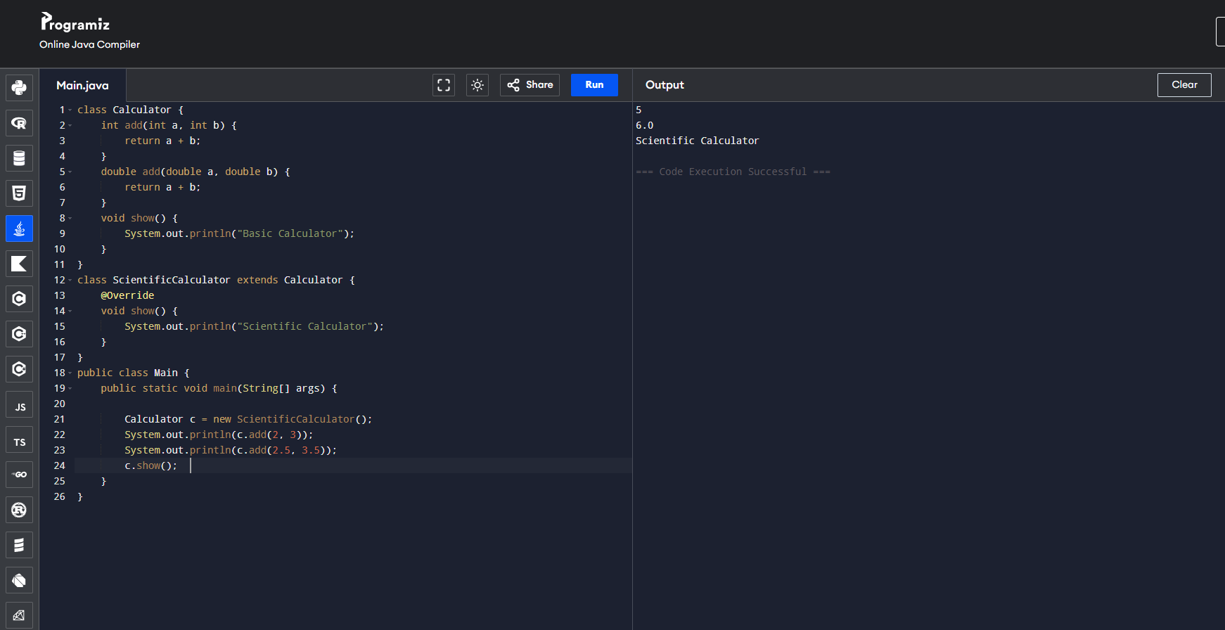

🔹 3. Employee System
class Employee {
// Overloading
void work() {
System.out.println("Employee working");
}
void work(int hours) {
System.out.println("Worked " + hours + " hours");
}
void salary() {
System.out.println("Employee Salary");
}
}
class Manager extends Employee {
// Overriding
void salary() {
System.out.println("Manager Salary: 50000");
}
}
public class Main3 {
public static void main(String[] args) {
Employee e = new Manager();
e.work(); // overloading
e.work(8); // overloading
e.salary(); // overriding
}
}
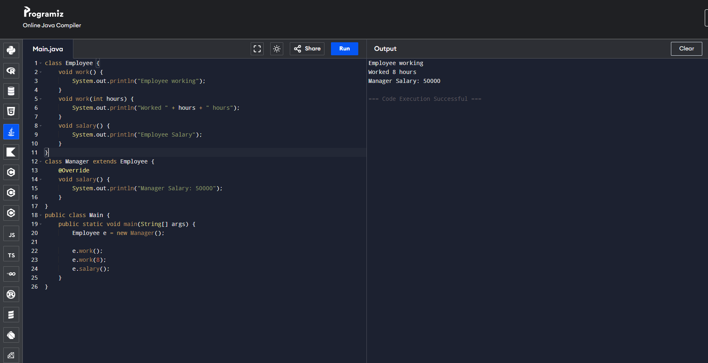

🔹 4. Vehicle System
class Vehicle {
// Overloading
void start() {
System.out.println("Vehicle starts");
}
void start(String mode) {
System.out.println("Vehicle starts with " + mode);
}
void fuel() {
System.out.println("Vehicle fuel");
}
}
class Car extends Vehicle {
// Overriding
void fuel() {
System.out.println("Car uses Petrol");
}
}
public class Main4 {
public static void main(String[] args) {
Vehicle v = new Car();
v.start(); // overloading
v.start("button"); // overloading
v.fuel(); // overriding
}
}
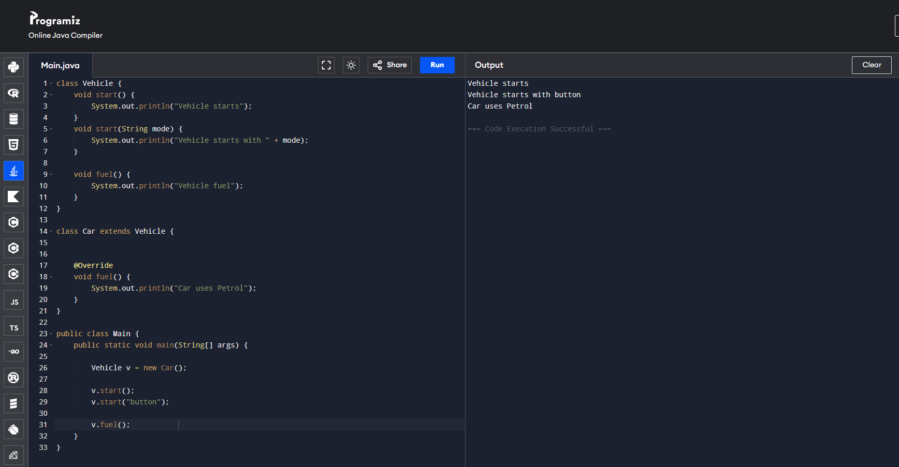

🔹 5. Bank System
class Bank {
// Overloading
void interest(int amount) {
System.out.println("Interest: " + (amount * 5 / 100));
}
void interest(int amount, int rate) {
System.out.println("Interest: " + (amount * rate / 100));
}
void display() {
System.out.println("Bank Info");
}
}
class SBI extends Bank {
// Overriding
void display() {
System.out.println("SBI Bank");
}
}
public class Main5 {
public static void main(String[] args) {
Bank b = new SBI();
b.interest(1000); // overloading
b.interest(1000, 7); // overloading
b.display(); // overriding
}
}
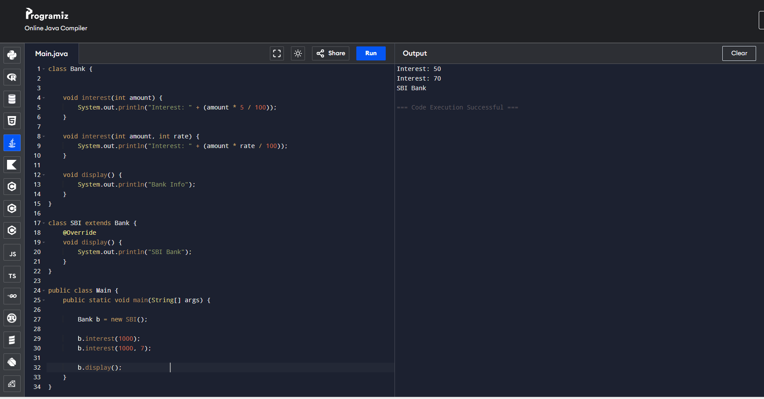

Overloading Method
Task 2 – Print Different Data Types
🔹 Question
Create a class PrintData to display different types of values:
- Display an integer
- Display a string
- Display a double value
Use the same method name for all.
🔹 Concepts Used
- Method Overloading
- Changing parameter types
- Output methods (System.out.println)
- Class and Object
✅ Task 3 – Salary Calculator
🔹 Question
- Create a class Salary:
- Method to display basic salary
- Method to calculate salary with bonus
Both methods should have the same name but different parameters.
🔹 Concepts Used
- Method Overloading
- Business logic (salary calculation)
- Different number of arguments
- Real-time scenario implementation

✅ Task 4 – Student Marks Total
🔹 Question
- Create a class Student:
- Calculate total marks for 2 subjects
- Calculate total marks for 3 subjects
- Use the same method name.
🔹 Concepts Used
- Method Overloading
- Arithmetic operations
- Different number of parameters
- Reusability of method names
✅ Task 5 – Parameter Order Change
🔹 Question

Create a class Example:

One method takes (int, String)
Another method takes (String, int)

Print the values accordingly.

🔹 Concepts Used
Method Overloading
Changing order of parameters
Method signature difference
Compile-time polymorphism
✅ Method Overloading in Java

Definition:
Method overloading means creating multiple methods with the same name but different parameters (type, number, or order) in the same class.

👉 It is called compile-time polymorphism because the method call is resolved during compilation.

🔹 Simple Example Program
class Calculator {

// Method with 2 integer parameters
int add(int a, int b) {
return a + b;
}

// Method with 3 integer parameters
int add(int a, int b, int c) {
return a + b + c;
}

// Method with double parameters
double add(double a, double b) {
return a + b;
}
}

public class Main {
public static void main(String[] args) {

Calculator obj = new Calculator();

System.out.println("Sum of 2 integers: " + obj.add(10, 20));
System.out.println("Sum of 3 integers: " + obj.add(10, 20, 30));
System.out.println("Sum of 2 doubles: " + obj.add(10.5, 20.5));
}
}
🔹 Output
Sum of 2 integers: 30
Sum of 3 integers: 60
Sum of 2 doubles: 31.0
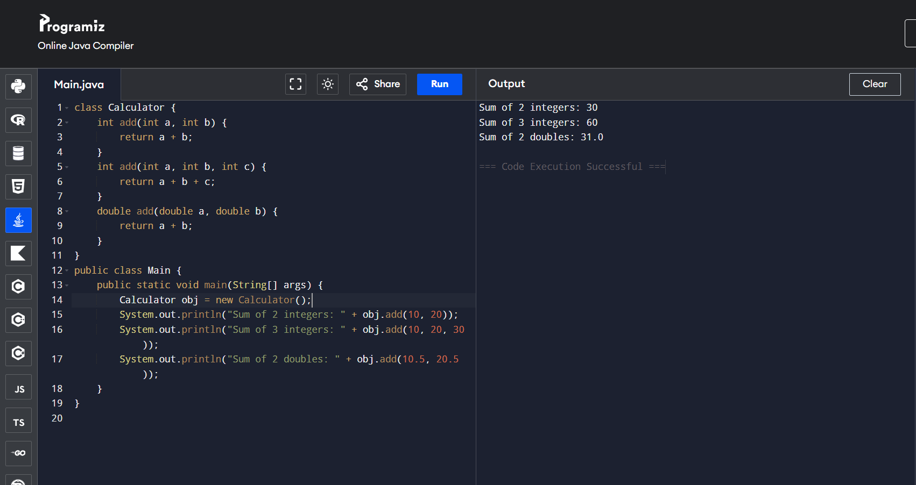
🔹 Key Points
Same method name → add()
Different parameters:
Number of arguments ✔
Type of arguments ✔
Return type alone cannot differentiate methods
🔹 Real-Time Example

Think of a calculator:

Add 2 numbers → add(int, int)
Add 3 numbers → add(int, int, int)
Add decimal numbers → add(double, double)

If you want, I can give you:
✅ 5 practice programs
✅ Interview questions on overloading
✅ Difference between overloading vs overriding (very important)

Five task using Overloading

Here are 5 practice tasks using Method Overloading in Java (with programs) — perfect for your learning and practice 👇

✅ Task 1 – Area Calculator

👉 Find area of different shapes using overloaded methods

class AreaCalculator {

// Area of square
void area(int side) {
System.out.println("Area of Square: " + (side * side));
}

// Area of rectangle
void area(int length, int breadth) {
System.out.println("Area of Rectangle: " + (length * breadth));
}

// Area of circle
void area(double radius) {
System.out.println("Area of Circle: " + (3.14 * radius * radius));
}
}

public class Main {
public static void main(String[] args) {
AreaCalculator obj = new AreaCalculator();

obj.area(5);
obj.area(10, 4);
obj.area(2.5);
}
} 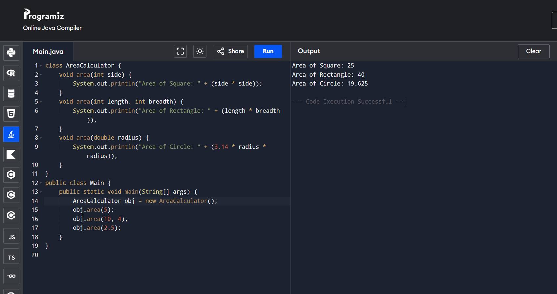

✅ Task 2 – Print Data

👉 Print different types of data
class PrintData {
void display(int a) {
System.out.println("Integer: " + a);
}
void display(String str) {
System.out.println("String: " + str);
}
void display(double d) {
System.out.println("Double: " + d);
}
}
public class Main {
public static void main(String[] args) {
PrintData obj = new PrintData();
obj.display(10);
obj.display("Hello Java");
obj.display(5.5);
}
} 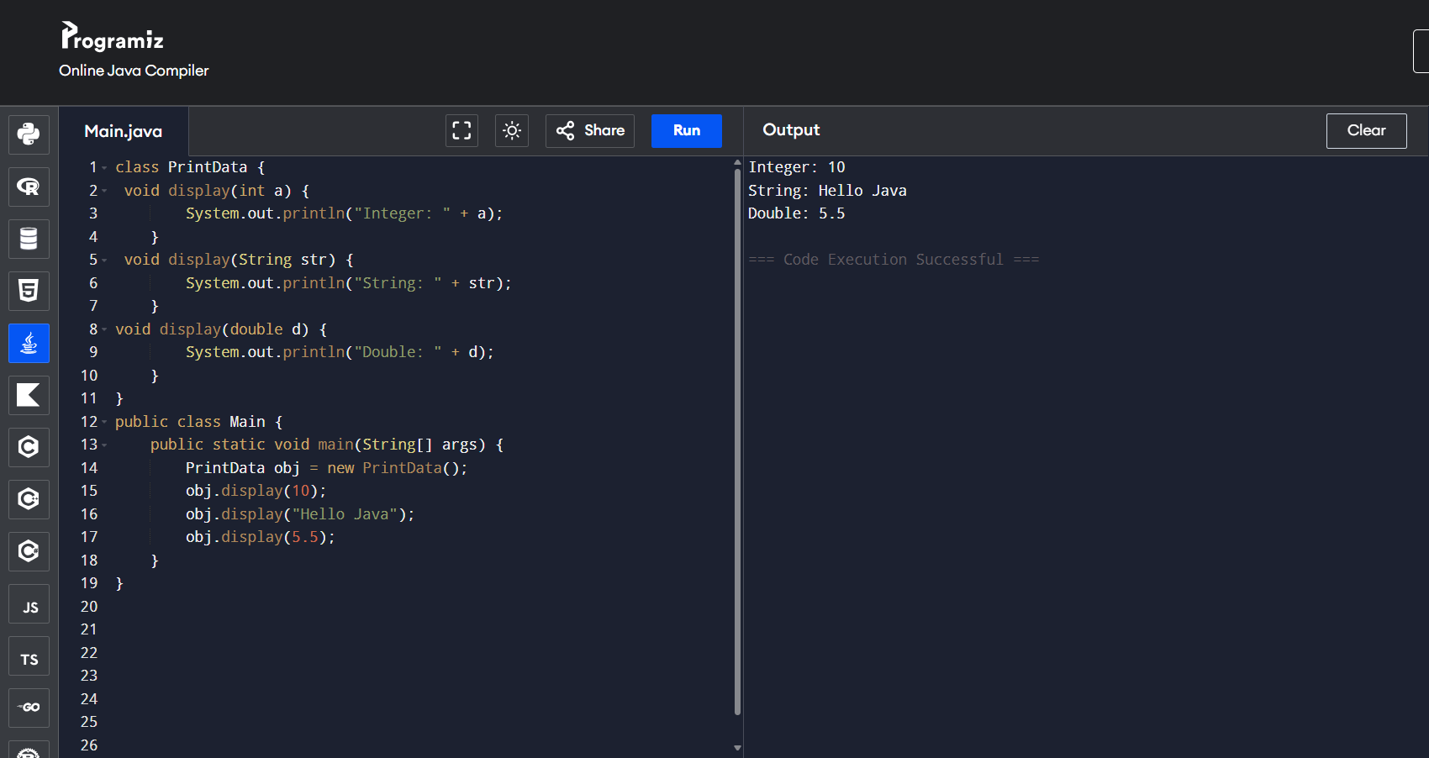

✅ Task 3 – Salary Calculator

👉 Calculate salary with bonus
class Salary {
void calculate(int salary) {
System.out.println("Salary: " + salary);
}
void calculate(int salary, int bonus) {
System.out.println("Salary with Bonus: " + (salary + bonus));
}
}
public class Main {
public static void main(String[] args) {
Salary obj = new Salary();
obj.calculate(20000);
obj.calculate(20000, 5000);
}
}
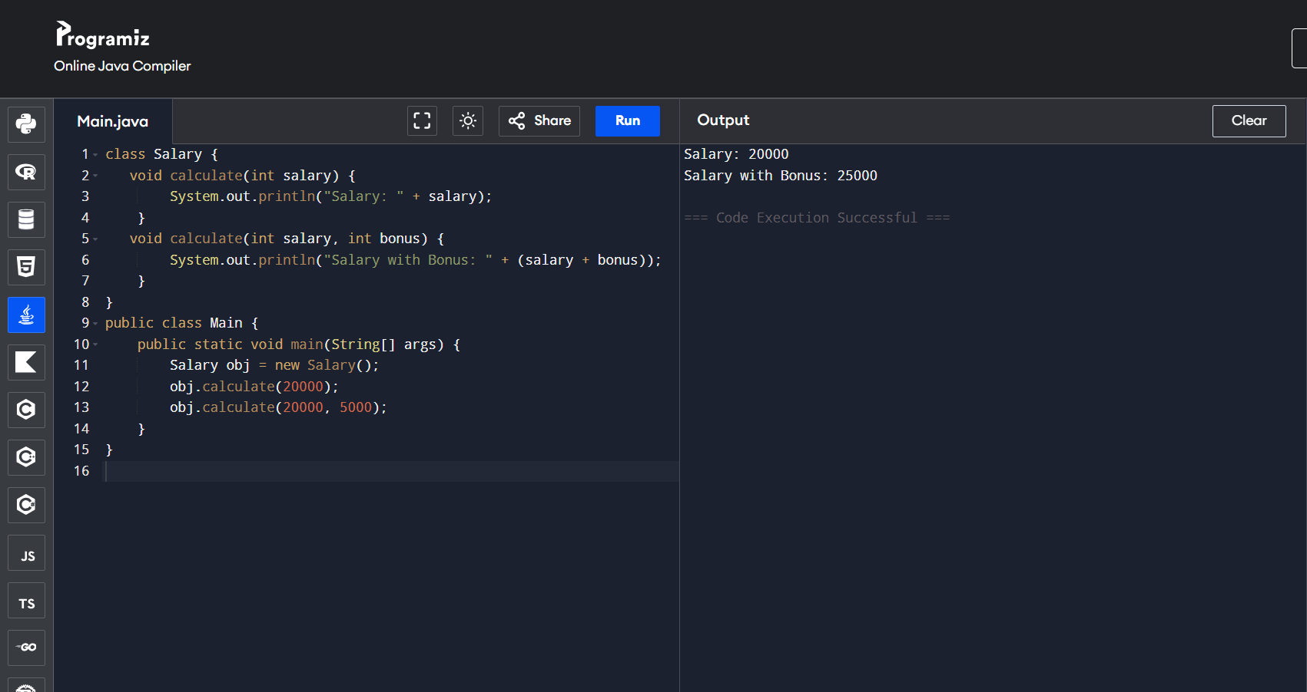
✅ Task 4 – Student Marks

👉 Calculate total marks

class Student {

void total(int m1, int m2) {
System.out.println("Total (2 subjects): " + (m1 + m2));
}

void total(int m1, int m2, int m3) {
System.out.println("Total (3 subjects): " + (m1 + m2 + m3));
}
}

public class Main {
public static void main(String[] args) {
Student obj = new Student();

obj.total(80, 90);
obj.total(80, 90, 85);
}
}
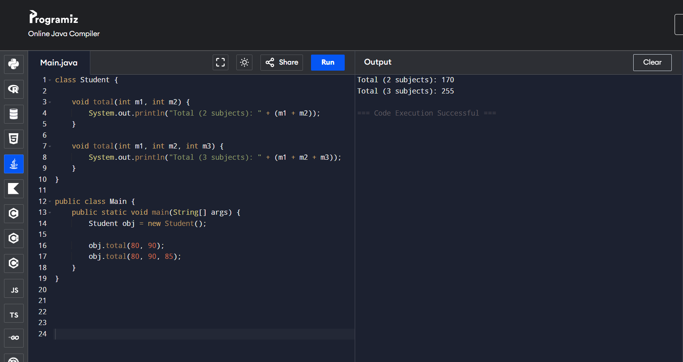

✅ Task 5 – Method Overloading with Different Order
class Example {
void show(int a, String b) {
System.out.println("Int then String: " + a + " " + b);
}
void show(String b, int a) {
System.out.println("String then Int: " + b + " " + a);
}
}
public class Main {
public static void main(String[] args) {
Example obj = new Example();
obj.show(10, "Java");
obj.show("Hello", 20);
}
}
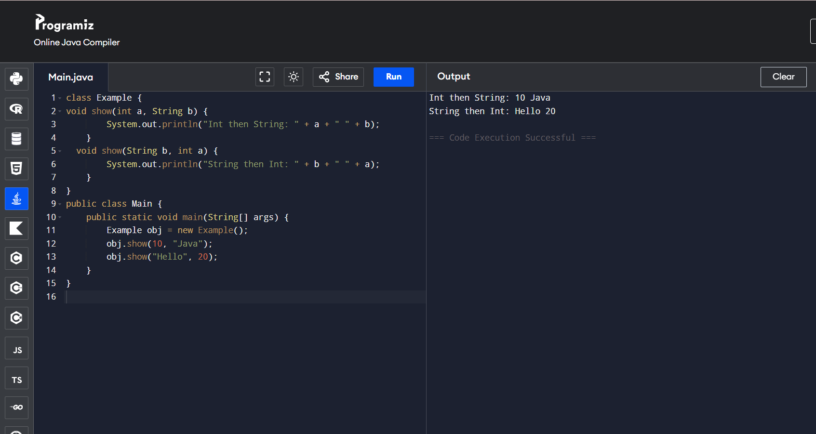
🔥 Summary

These tasks cover:

Different number of parameters ✔
Different data types ✔
Different order of parameters ✔

If you want next level:
👉 I can give real interview questions
👉 Or mini project using overloading
👉 Or tricky MCQs for exams

Give me the task question and concepts for this program

Great 👍 You want only the task questions + concepts (not the code). Here are the same 5 tasks rewritten clearly for practice:

✅ Task 1 – Area Calculator
🔹 Question

Create a class AreaCalculator that calculates the area of different shapes using method overloading:

Calculate area of a square (1 parameter)
Calculate area of a rectangle (2 parameters)
Calculate area of a circle (1 double parameter)
🔹 Concepts Used
Method Overloading (same method name area)
Different number of parameters
Different data types (int, double)
Class and Object
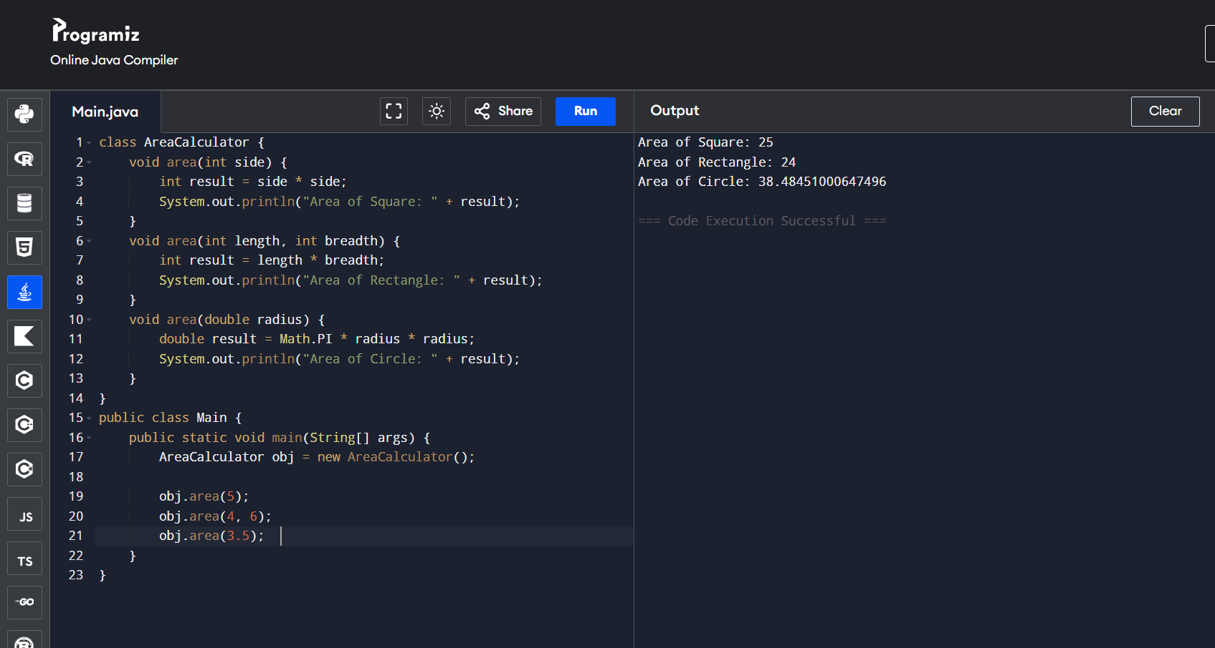
✅ Task 2 – Print Different Data Types
🔹 Question

Create a class PrintData to display different types of values:

Display an integer
Display a string
Display a double value

Use the same method name for all.

🔹 Concepts Used
Method Overloading
Changing parameter types
Output methods (System.out.println)
Class and Object
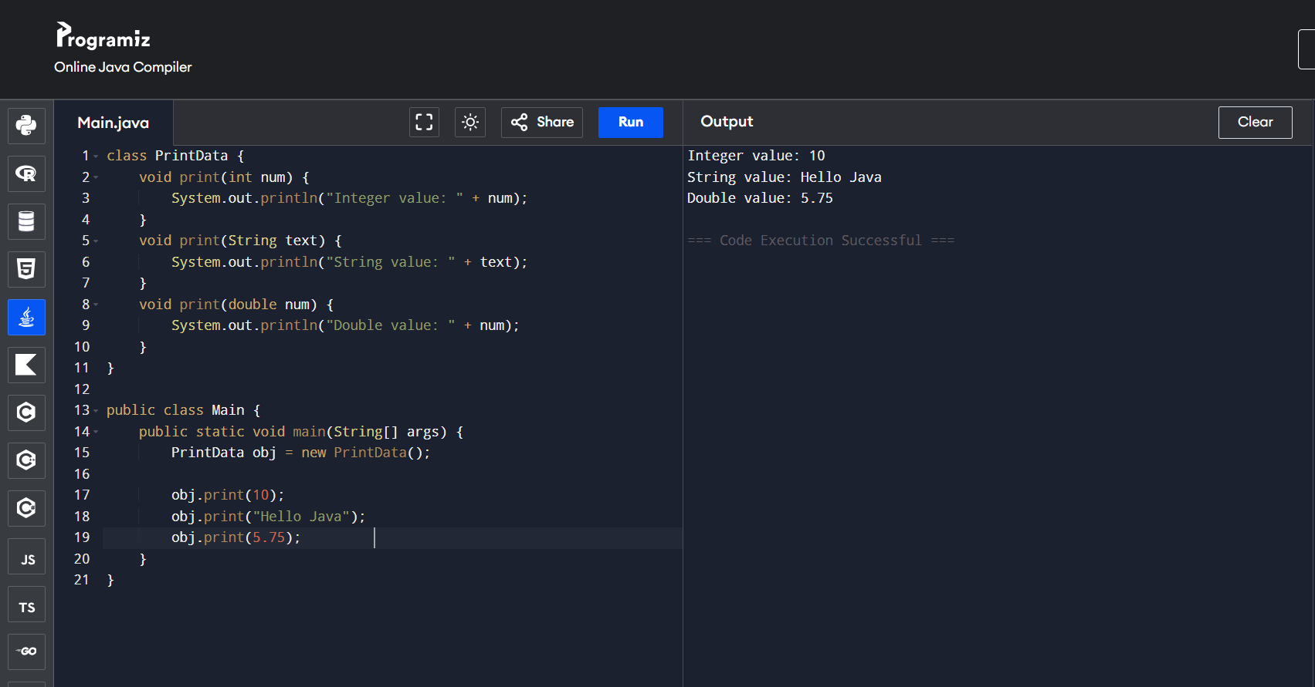
✅ Task 3 – Salary Calculator
🔹 Question

Create a class Salary:

Method to display basic salary
Method to calculate salary with bonus

Both methods should have the same name but different parameters.

🔹 Concepts Used
Method Overloading
Business logic (salary calculation)
Different number of arguments
Real-time scenario implementation
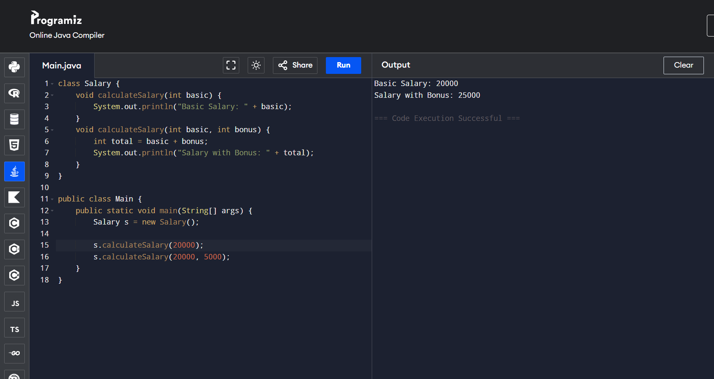
✅ Task 4 – Student Marks Total
🔹 Question

Create a class Student:

Calculate total marks for 2 subjects
Calculate total marks for 3 subjects

Use the same method name.

🔹 Concepts Used
Method Overloading
Arithmetic operations
Different number of parameters
Reusability of method names
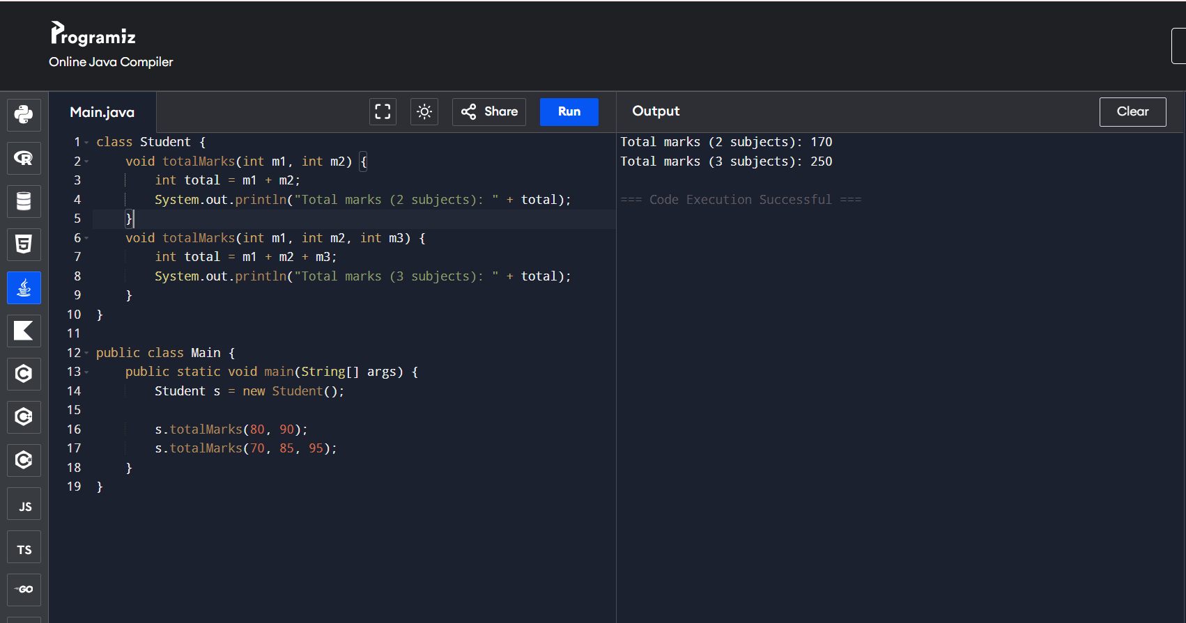
✅ Task 5 – Parameter Order Change
🔹 Question

Create a class Example:

One method takes (int, String)
Another method takes (String, int)

Print the values accordingly.

🔹 Concepts Used
Method Overloading
Changing order of parameters
Method signature difference
Compile-time polymorphism
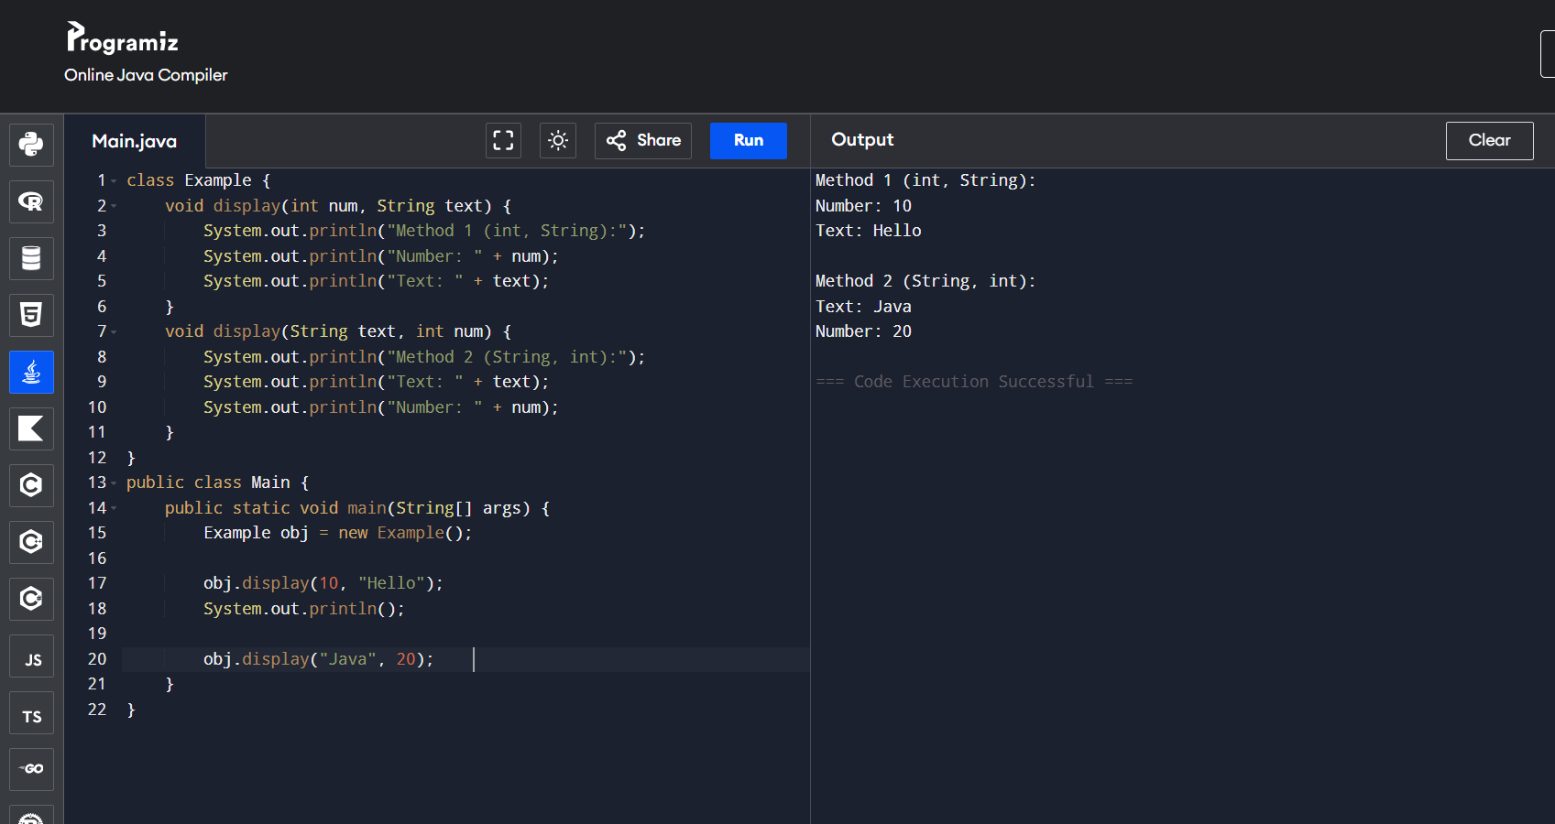

Overriding Method

🔹 Task 1: Animal Sound
🎯 Task
Create a parent class Animal with method sound().
Create child classes Dog and Cat that override it.
class Animal {
void sound() {
System.out.println("Animal makes sound");
}
}
class Dog extends Animal {
void sound() {
System.out.println("Dog barks");
}
}
class Cat extends Animal {
void sound() {
System.out.println("Cat meows");
}
}
public class Task1 {
public static void main(String[] args) {
Animal a;
a = new Dog();
a.sound();
a = new Cat();
a.sound();
}
}

🔹 Task 2: Vehicle Start
🎯 Task
Create Vehicle class with start() method.
Override in Car and Bike.
class Vehicle {
void start() {
System.out.println("Vehicle starts");
}
}
class Car extends Vehicle {
void start() {
System.out.println("Car starts with key");
}
}
class Bike extends Vehicle {
void start() {
System.out.println("Bike starts with self-start");
}
}
public class Task2 {
public static void main(String[] args) {
Vehicle v;
v = new Car();
v.start();
v = new Bike();
v.start();
}
}

🔹 Task 3: Shape Display
🎯 Task
Create Shape class with draw() method.
Override in Circle and Rectangle.
class Shape {
void draw() {
System.out.println("Drawing shape");
}
}
class Circle extends Shape {
void draw() {
System.out.println("Drawing Circle");
}
}
class Rectangle extends Shape {
void draw() {
System.out.println("Drawing Rectangle");
}
}
public class Task3 {
public static void main(String[] args) {
Shape s;
s = new Circle();
s.draw();
s = new Rectangle();
s.draw();
}
}

🔹 Task 4: Bank Interest
🎯 Task
Create Bank class with interest() method.
Override in SBI and HDFC.
class Bank {
void interest() {
System.out.println("Bank interest");
}
}
class SBI extends Bank {
void interest() {
System.out.println("SBI Interest: 6%");
}
}
class HDFC extends Bank {
void interest() {
System.out.println("HDFC Interest: 7%");
}
}
public class Task4 {
public static void main(String[] args) {
Bank b;
b = new SBI();
b.interest();
b = new HDFC();
b.interest();
}
}

🔹 Task 5: Student Result
🎯 Task
Create Student class with result() method.
Override in SchoolStudent and CollegeStudent.
class Student {
void result() {
System.out.println("Student result");
}
}
class SchoolStudent extends Student {
void result() {
System.out.println("School Student: Pass");
}
}
class CollegeStudent extends Student {
void result() {
System.out.println("College Student: Distinction");
}
}
public class Task5 {
public static void main(String[] args) {
Student s;
s = new SchoolStudent();
s.result();
s = new CollegeStudent();
s.result();
}
}

🔥 Common Pattern (Very Important)
Parent ref;
ref = new Child1();
ref.method();
ref = new Child2();
ref.method();
👉 This is Run-Time Polymorphism

